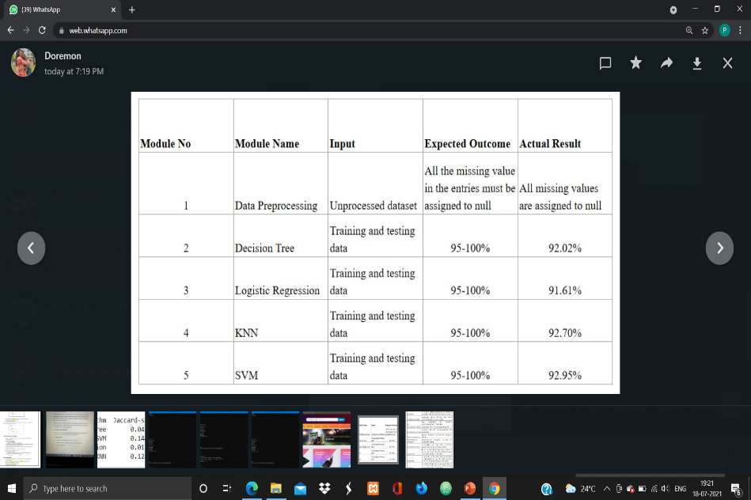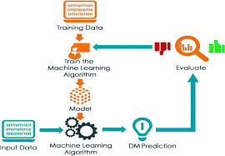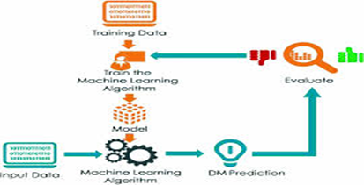

**ANALYSIS & DETECTION OF DDOS ATTACK USING MACHINE LEARNING TECHNIQUES**

**System Design & Implementation**

Distributed Denial of Service attacks fall under the category of critical attacks that compromise the supply of the network.

DDos attacks continue to grow rapidly so to detect and mitigate these attacks became a challenging task. This work is carried out on a portal built on local server and a brand-new dataset will be generated with Intrusion Detection System.

Tor Hammer tool was used as an attacking mechanism.

The work incorporates various machine learning algorithms: Support Vector Machine, Decision Tree, KNN and Logistic Regression for classification.





Result & Analysis

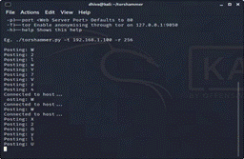

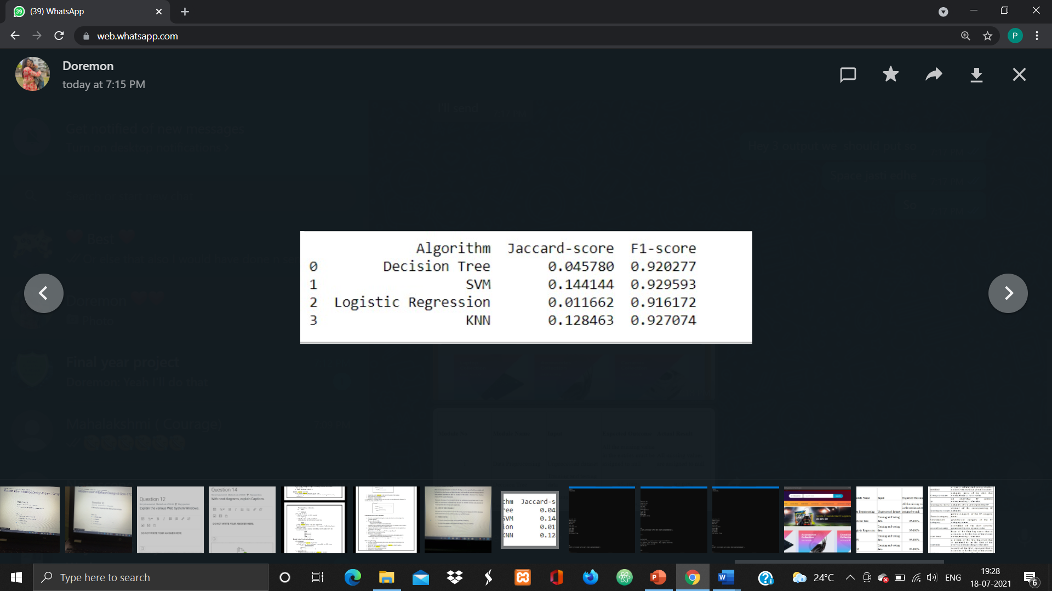

**Applications & Conclusion**

**Abstract**

**Conclusion**

Machine learning classification algorithms were applied to the data set namely Support Vector Machine, Decision tree, KNN and Logistic Regression. After considering all the algorithms and implementing them in the model SVM algorithm showed greater results compared to other algorithms.

**INDIVIDUAL CONTRIBUTION**

DHIVAKAR AK: Attack Simulation (Tor Hammer Tool)

PRUTHVI S: Data Preprocessing (Weka Tool)

SANTHOSH E: Data Collection (Snort)

SHREYA M: Classification

TEAM MEMBERS:

1. DHIVAKAR A K (1EP17CS019)
2. PRUTHVI S (1EP17CS063)
3. SANTHOSH E (1EP17CS076)
4. SHREYA M (1EP17CS082)

UNDER THE GUIDANCE OF:

DR. EMILIN SHYNI C

PROFESSOR, DEPT OF CSE

GUIDE NAME:

**Tools Used**

1. Tor Hammer Tool
2. Intrusion Detection System SNORT
3. WEKA Tool
4. Jupyter Notebook
5. Linux Operating System

**Objectives**

**Problem Statement**

The main aim of our project is to process newly generated dataset for DDOS detection and to increase the accuracy of the detection rate in DDOS attack.

Our other main objectives are to, identify whether the traffic data is suspicious or normal, To reduce false negative rate in distributed denial of service ( DDOS ) and to get good detection rate.

To identify whether the traffic data is suspicious or normal.

Classification algorithms are very important category of supervised machine learning algorithms.

Algorithms Support Vector Machine, Decision Tree, KNN and Logistic Regression for classification.

are used for the detection of ddos attack.

These Algorithms are used to identify whether the traffic data is suspicious or normal.

**Results and Analysis**